**Objective:-** Get value from user and create session in another jsp page and also view. (JSP)

**Code :-**

**src/main/webapp/index.jsp**

<html>  
<body>  
<h2>JSP Session Management</h2>  
<form action="setSession.jsp" method="post">  
 <label>  
 First Name: <input type="text" name="first_name">  
 </label><br/>  
 <label>  
 Last Name: <input type="text" name="last_name">  
 </label><br/>  
 <input type="submit" value="Submit">  
</form>  
</body>  
</html>

**src/main/webapp/setSession.jsp**

<%@ page contentType="text/html;charset=UTF-8" language="java" %>  
<%  
 // Set session attributes for first and last names.  
 session.setAttribute("first_name", request.getParameter("first_name"));  
 session.setAttribute("last_name", request.getParameter("last_name"));  
%>  
<html>  
<head>  
 <title>Set Session</title>  
</head>  
<body>  
 <h1>Session created successfully</h1>  
 <a href="readSession.jsp">Read session</a>  
</body>  
</html>

**src/main/webapp/readSession.jsp**

<%@ page contentType="text/html;charset=UTF-8" language="java" %>  
<html>  
<head>  
 <title>Read Session</title>  
</head>  
<body>  
<%  
 // Retrieve session attributes for first and last names.  
 String firstName = (String) session.getAttribute("first_name");  
 String lastName = (String) session.getAttribute("last_name");  
  
 // Check if session attributes are not null.  
 if (firstName != null && lastName != null) {  
 out.println("First Name: " + firstName + "<br/>");  
 out.println("Last Name: " + lastName + "<br/>");  
 } else {  
 out.println("<h2>No session data found</h2>");  
 }  
%>  
</body>  
</html>

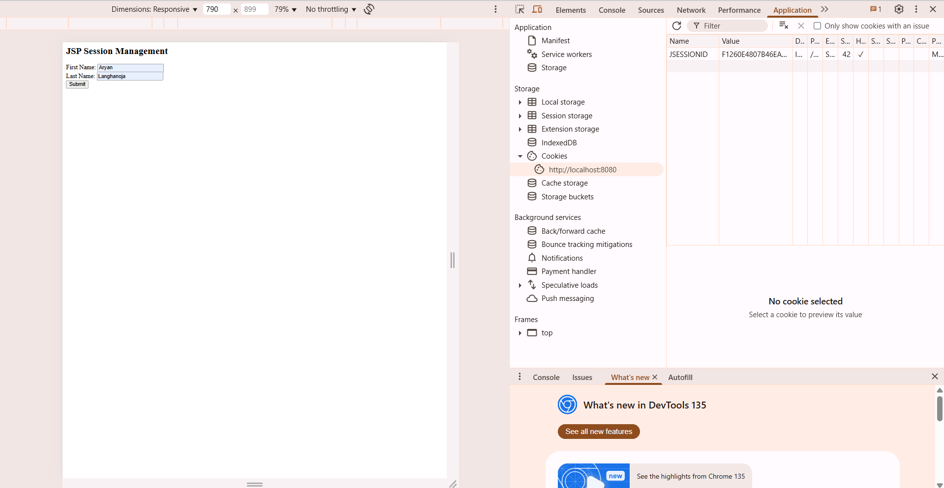**Output:-**

